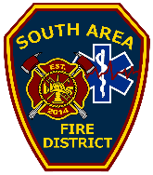
Media Interview Request Form

Reporter’s Name:________________________________________________________

Reporter’s Phone: _______________ Reporter’s E-mail:_________________________

Name of Media Outlet:____________________________________________________

Type of Media the interview will appear on:

q Television q Newspaper q Radio q Magazine q Web News

Interview time and date requested:

TIME:_____________ DATE:_____________

Topic, :____________________________________________________

Specific question(s):
__________________________________________________________________________________________________________________________________________________________________________________________________________________________________________________________________________________________________________________________________________________________________________________________________________________________________________________________________________________________________________

Format:
q Live q Phone q Audio Recorded q Panel q Videotaped q In Person q Online

Email completed forms to kchula@saferdistrict.org

We believe in open communication and strive to be timely and accurate in response to media requests for information and interviews. Please remember, the safety and protection of our community is our first priority. Please allow up to two business days for a response.

